Ratan Tata, former Chairman of Tata Sons, passed away at 86 on October 9, 2024, in Mumbai. A renowned industrialist and philanthropist, Tata led Tata Group to global success and invested in numerous ventures. His death marks a significant loss to India's business world and philanthropy.

RARAN TATA’S

Born on 28 December 1937 in Bombay, British India (present-day Mumbai), Ratan Tata is the son of Naval Tata and Sooni Commissariat. They got separated when Ratan Tata was 10 years old. He was then formally adopted by his grandmother Navajbai Tata through the J. N. Petit Parsi Orphanage. Ratan Tata was raised with his half-brother Noel Tata (son of Naval Tata and Simone Tata). He joined Tata Sons in 1962, where he worked on the floor. It was a strenuous and difficult job, but he gained experience and understanding of the family business.

In 1971, he was made Director-in-charge of the NELCO (National Radio and Electronics Company Ltd). The company was going through a financial crisis phase. Ratan Tata worked hard to build an improved consumer electronics division, but the economic recession and Union issues did not prove successful.

In 1977, he was transferred to Empress Mills, another struggling Tata Group unit. He made a plan for the mill’s revival, but the other company executives rejected it, and the mill was shut down. Ratan Tata was yet again moved to Tata Industries.

In 1991, JRD Tata appointed Ratan Tata the Chairman of the Tata Group. There were objections from other executives concernregarding his ability to manage the responsibilities. Once at the Tata Group’s helm, Ratan Tata successfully improved the organisation’s overall position**.**

In 1977, he was transferred to Empress Mills, another struggling Tata Group unit. He made a plan for the mill’s revival, but the other company executives rejected it, and the mill was shut down. Ratan Tata was yet again moved to Tata Industries.

In 1991, JRD Tata appointed Ratan Tata the Chairman of the Tata Group. There were objections from other executives amid concern regarding his ability to manage the responsibilities. Once at the Tata Group’s helm, Ratan Tata successfully improved the organisation’s overall position**.**

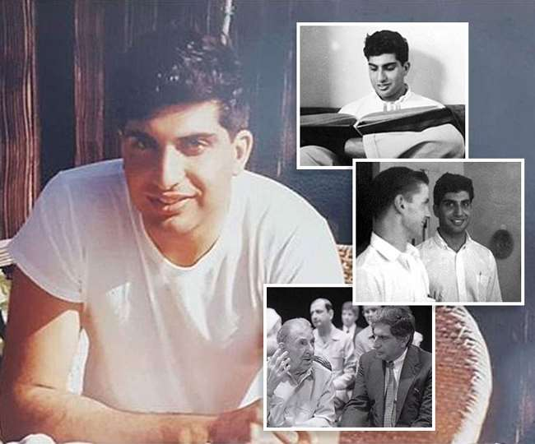

In 1977, he was transferred to Empress Mills, another struggling Tata Group unit. He made a plan for the mill’s revival, but the other company executives rejected it, and the mill was shut down. Ratan Tata was yet again moved to Tata.

### In 1991, JRD Tata appointed Ratan Tata the Chairman of the Tata Group. There were objections from other executives amid concern regarding his ability to manage the responsibilities. Once at the Tata Group’s helm, Ratan Tata successfully. The journey begins when Mr. JRD Tata Chairman of Tata Sons stepped down and Mr. Ratan Tata took over as his successor in the year 1991. This news came as a surprise for many as the existing executives like Russi Mody (Tata Steel), Darbari Seth(Tata Tea, Tata Chemicals), Ajit Kerkar(Taj Hotels) and NaniPalkhivala(Director on boards of several Tata Companies) were expected to succeed JRD Tata. This news led to a bitter feud among the group and many disagreed with the decision.

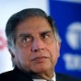

### In the capacity of Tata Group’s Chairman, he took the company to s

**Ratan Tata - Major Successes**

**Ratan Tata - Major Successes**

In the capacity of Tata Group’s Chairman, he took the company to such heights that it was prestigiously recognized at the international level. The company achieved great financial success, and the Tata Group reached the New York Stock Exchange. Under his leadership, Tata Group became a global brand with its acquisition of companies such as Corus, Jaguar Land Rover, and Tetley. The Tata Nano and Tata Indica automobiles were conceived and built under his leadership.

A major philanthropist, he has invested over 65 percent of his share in charitable trusts. A key goal of his life is to give Indians a better quality of life and ensure human development.

* Padma Bhushan (3rd highest civilian honour of the Govt. of India (2000)).
* Medal of the Oriental Republic of Uruguay (Govt. of Uruguay (2004)).
* International Distinguished Achievement Award (B’nai B’rith International (2005)).
* Honorary Fellowship of The London School of Economics and Political Science (2007).
* Padma Vibhushan (2nd highest civilian honour of the Govt. of India (2008)).
* Award of ‘Grand Officer’ of the Order of Merit of the Italian Republic (Government of Italy (2009)).
* Title of Honorary Knight Commander of the Order of the British Empire, United Kingdom (2009).
* Oslo Business for Peace Award (Business for Peace Foundation (2010)).
* Honorary Knight Grand Cross of The Order of the British Empire (2014).

### 